To permanently delete a Git repository in Azure DevOps, navigate to the project's "Repos" section, manage repositories, select the repository, and choose "Delete repository" from the "..." menu. Confirm the deletion by typing the repository name and clicking "Delete", [according to Learn Microsoft](https://learn.microsoft.com/en-us/azure/devops/repos/git/delete-existing-repo?view=azure-devops).

Here's a more detailed breakdown:

1. **Access Repos:** Go to your Azure DevOps project and navigate to the "Repos" section.
2. **Manage Repositories:** From the repo dropdown, select "Manage repositories".
3. A screenshot of a computer

   AI-generated content may be incorrect.
4. **Select Repository:** Locate the repository you want to delete in the list and click the "..." menu next to it.
5. 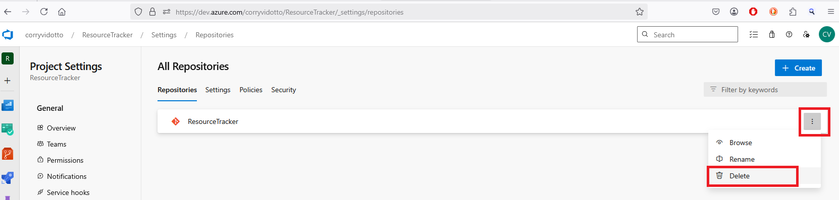
6. **Delete Repository:** Choose "Delete repository" from the menu.
7. ***\*Note:*** *you cannot delete a repository if it is the only one in a project. So, created a new repository then you can delete the old/original one.*
8. **Confirm Deletion:** You will be prompted to confirm the deletion. Type the repository's name exactly as it appears and click "Delete".

Important Notes:

* **Permanently Deleted:**

Once you confirm the deletion, the repository will be permanently removed and cannot be restored.

* **Permissions:**

You must have the necessary permissions to delete a repository in Azure DevOps.

* **TFVC Repositories:**

You cannot delete TFVC repositories in Azure DevOps once they have been created, [according to Learn Microsoft](https://learn.microsoft.com/en-us/azure/devops/repos/tfvc/destroy-command-team-foundation-version-control?view=azure-devops). The tf destroy command only destroys version-controlled files and folders, not the repository itself.

* **Project Deletion:**

Deleting a project in Azure DevOps also permanently deletes all of its repositories after 28 days, [according to Learn Microsoft](https://learn.microsoft.com/en-us/azure/devops/organizations/projects/delete-project?view=azure-devops).

This video demonstrates how to delete a repository in Azure DevOps:

](https://www.youtube.com/watch?v=L73pjakH-do&t=56)

[15s](https://www.youtube.com/watch?v=L73pjakH-do&t=56)

[](https://www.youtube.com/watch?v=L73pjakH-do&t=56)

[](https://www.youtube.com/watch?v=L73pjakH-do&t=56)

[Bharat Ki Baat](https://www.youtube.com/watch?v=L73pjakH-do&t=56)

[YouTube · May 5, 2023](https://www.youtube.com/watch?v=L73pjakH-do&t=56)

* Delete a Git repo from your project - Azure - Learn Microsoft

From the repo drop-down, select Manage repositories. Select the name of the repository from the Repositories list, choose the ...



Learn Microsoft

* How to delete a Git repository in Azure DevOps?

Oct 26, 2018



Stack Overflow

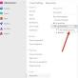

* Delete, remove, restore project - Azure DevOps - Learn Microsoft

Mar 12, 2025 — Q: I deleted a project in Azure DevOps, but in Visual Studio Team Explorer it's still there, what do I do? A: Wait 28 ...



Learn Microsoft

* Show all